EUROPEAN AND MEDITERRANEAN PLANT PROTECTION ORGANIZATION

ЕВРОПЕЙСКАЯ И СРЕДИЗЕМНОМОРСКАЯ ОРГАНИЗАЦИЯ ПО КАРАНТИНУ И ЗАЩИТЕ РАСТЕНИЙ

ORGANIZATION EUROPEENNE ET MEDITERRANEENNE POUR LA PROTECTION DES PLANTES

03/10063e
Panel on QPF Point 5.1.5

Data Sheets on Forest Pests

Ceroplastes sinensis

IDENTITY

Name: Ceroplastes sinensis Del Guercio

Synonym: not known

Taxonomic position: Insecta: Coccidae, Homoptera.

Common name: Chinese wax scale, Citrus wax scale (English), Китайская восковая ложнощитовка, цитрусовая восковая ложнощитовка (Russian).

Bayer computer code: CERPSI

HOSTS

C. sinensis is a highly polyphagous pest. According to different authors it damages 30 to 137 species of plants. It prefers different Citrus species (especially Citrus sinensis), Punica granatum, Laurus nobilis, Diospyros kaki, Camellia sinensis, Eriobotrya japonica, Juglans regia, Prunus persica, Pyrus spp. and many other plants including forest and ornamental woody and herbaceous plants. On herbaceous plants, the pest may develop only larvae of the first and the second stages (Rubtsov, 1954; Dzhashi, 1955; Tsintsadze, 1971; Chanishvili, 1972, 1981; Borhsenius, 1973; Katsitadze, 1975; Sinadskii, 1982; Pelizzari & Camporese, 1994)

GEOGRAPHICAL DISTRIBUTION

EPPO region: Azerbaijan (potential EPPO member, introduced), Georgia including Adzharia and Abkhasia (potential EPPO member, introduced), France, Italy, Spain, Morocco, Portugal, southern Russia (introduced), Syria (potential EPPO member), Tunisia, Tajikistan (potential EPPO member, introduced), Uzbekistan (potential EPPO member, introduced) (Borhsenius, 1937; Bodenheimer, 1951; Rubtsov, 1954; Dzhashi, 1955; Batiashvili, 1965; Shutova, 1970; Lobzhanidze, 1975; Panis, 1980; Chanishvili, 1981; Bassova, 1983b; Orlinskii, 1987; Orlinskii, Bassova & Shahramanov, 1993; Pelizzari, Camporese, 1994)

Asia: Azerbaijan (introduced), China, Georgia including Adzharia and Abkhasia (introduced), India, Iran, Japan, Syria, Turkey, Viet Nam (Borhsenius, 1937; Bodenheimer, 1951; Rubtsov, 1954; Dzhashi, 1955; Batiashvili, 1965; Lobzhanidze, 1975; Chanishvili, 1981; Bassova, 1983b; Orlinskii, 1987; Orlinskii, Bassova & Shahramanov, 1993; Pelizzari, Camporese, 1994)

Africa: Algeria, Benin, Egypt, Cot d’Ivoire, Mozambique, Togo (Pelizzari & Camporese, 1994).

Oceania: Australia, Hawaii, New Zealand (Pelizzari & Camporese, 1994).

South America: Brazil (Pelizzari & Camporese, 1994).

North America: Mexico, USA (Pelizzari & Camporese, 1994).

EU: France, Italy, Spain, Portugal (Panis, 1980; Pelizzari & Camporese, 1994).

C. sinensis, first described by Del Guercio in 1901, originates according to some authors from southern China (Borhsenius, 1937), but according to other authors – from the South of the USA and/or Caribbean Islands (Pelizzari & Camporese, 1994). On the territory of the former USSR, the pest was first detected in 1913 in Adzharia and in 1920 – in Abkhasia.

BIOLOGY

In subtropics of the former USSR and throughout its distribution areas, C. sinensis develops 1 generation per year. Overwintering stage are usually larvae of 2nd – 3rd instars (sometimes pronymphs). In Georgia (Adzharia), they become active at the average temperature + 15° С in the end of March – beginning of April, in more cold regions – in the second half of April. The oviposition begins in the end of May and lasts till the end of October. Mass oviposition occurs in June – July. The development of first instar larvae takes in average 28 days, 2nd instar – 30 days, 3rd instar – 35 days. The adult female appears 94 days after the larva hatches from the egg. The development of male larvae takes 73 days. The scale is bisexual, but males are usually present in a low percentage and are not necessary for the propagation so that it is generally assumed that mainly parthenogenesis occurs. The optimal conditions for the development of C. sinensis are: temperature 22,4 – 26,0ºС and air humidity 70 – 80%. The pest is not as cold resistant as C. japonicus but the winter mortality usually doesn’t exceed 22% (in Adzharia). The fecundity and the sex rate depend much on the host plant like C. japonicus. The average fecundity of the pest is 715 eggs per female on feijoa, 794 on pear, 976 on lemon, 1066 on orange, 1148 on pomegranate, 1270 on laurel, 2120 on quince, 3628-5080 on tangerine. The average sex rate (females : males) is 9:1 on tangerine, 7:1 on quince, 6:1 on feijoa, 4:1 on pear (Georgebiani & Yasnosh, 1949; Dzhashi, 1955; Chanishvili, 1981; Pelizzari & Camporese, 1994).

DETECTION AND IDENTIFICATION

Symptoms

Females and larvae of C. sinensis are easily detected on leaves and branches (Fig. 1). Host plants are covered by black fungi (?) developing on honeydew excreted by wax scales.

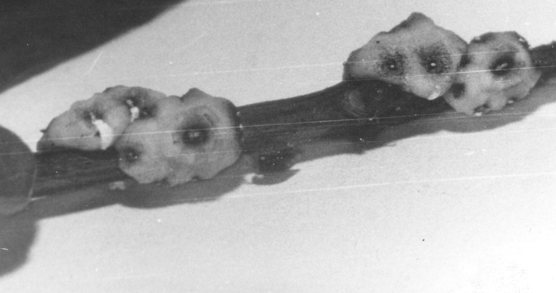 | 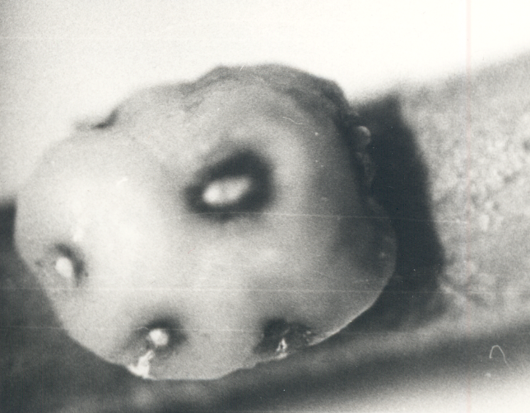
1 2

Fig. 1 Females of C. sinensis on branches of pomegranate (1) and tangerine (2) (Bassova, 1983b)

Morphology

Eggs

Eggs of C. sinensis are less than 0,5 mm long. One female may lay till 5000 eggs (Dzhashi, 1955; Chanishvili, 1981).

Larva

Neonate larvae of C. sinensis hatching from eggs have well developed legs and antennae. They move actively searching suitable places for feeding. Than they fixes themselves on the surface of plants and turn into immovable larvae, which have a form of small stars.

Pupa

The stage of pupa doesn’t exist.

Adult

The adult female of C. sinensis (Fig. 1 & 2) is oval, 2 – 5 mm long, dorsal side is prominent, ventral side is flat. The upper side of the body is covered by a thick layer of wax, which is usual for all Ceroplastes species. The surface is more prominent in the centre and less prominent at the borders where the colour of the wax cover is more dark because the layer of wax is thinner and the dark red body is seen through it. Legs and 7-segmented antennae are clearly seen on the flat ventral side of the scale. The female lays eggs under its body. During the oviposition, the body is pressed toward the dorsal side. At the end of the oviposition, the female is transformed in a capsule filled by eggs (Shutova, 1970). More detailed morphological description is published by Pelizzari & Camporese (1994).

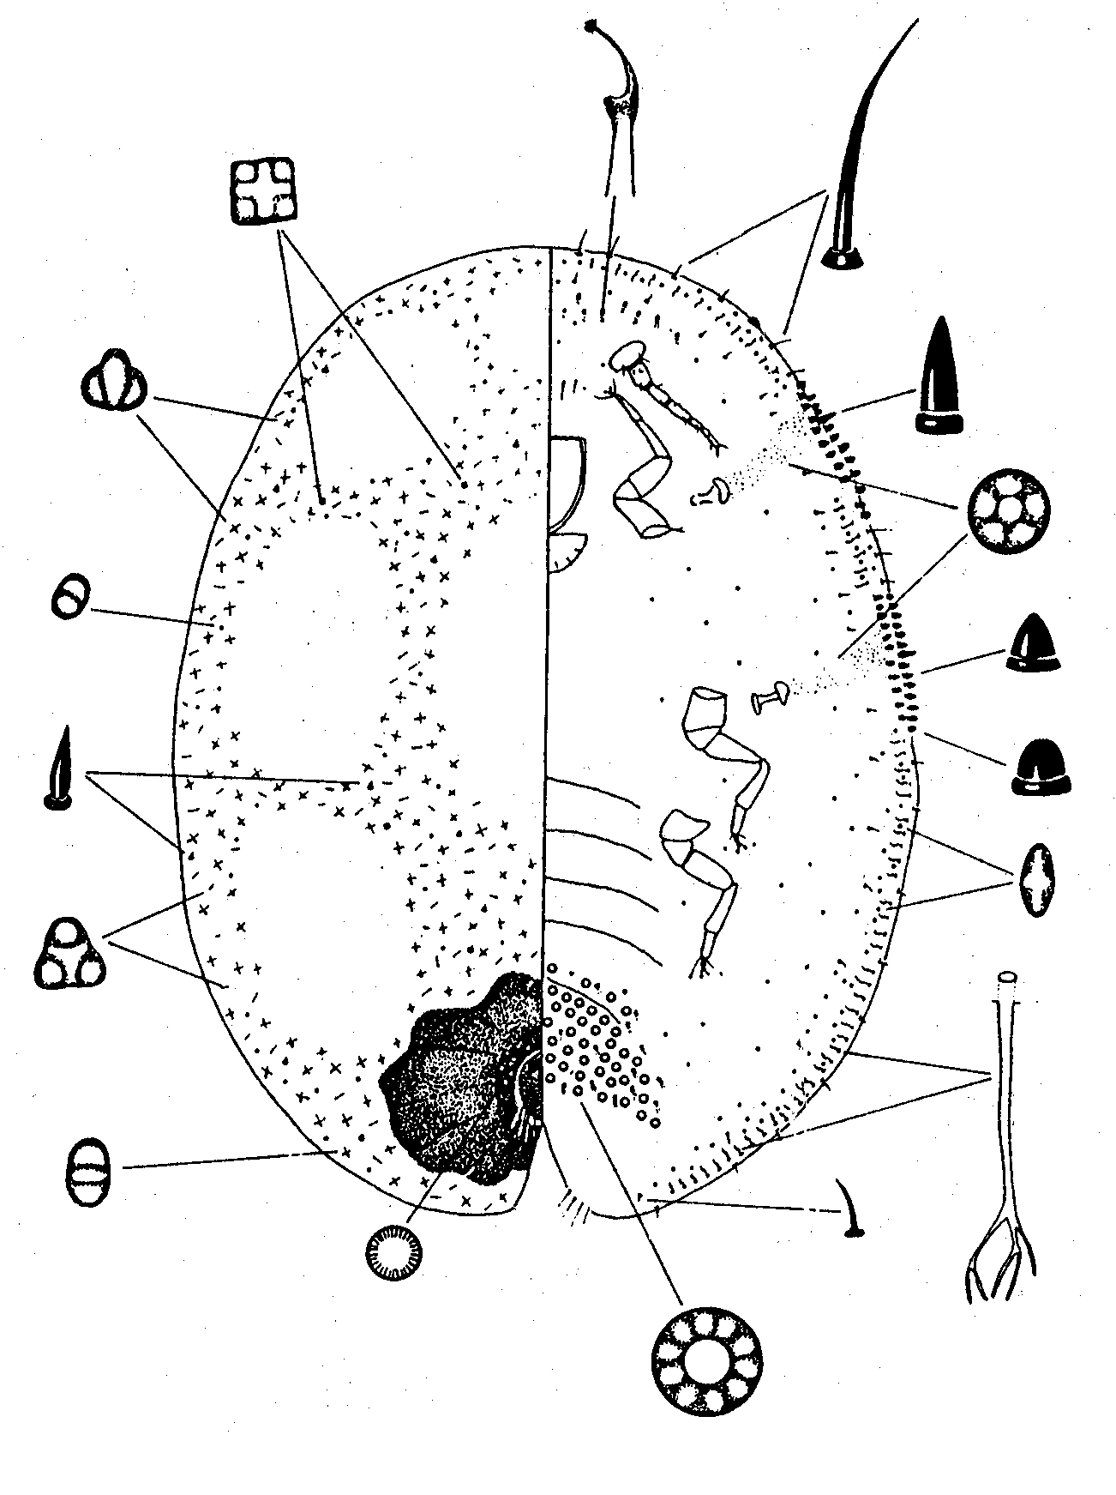

Fig. 2 Structure of a female of C. sinensis (Pelizzari & Camporese, 1994)

MEANS OF MOVEMENT AND DISPERSAL

C. sinensis spreads mainly with plants for planting. Natural spread to very short distances is possible with neonate larvae.

PEST SIGNIFICANCE

Economic Impact

C. sinensis is one of the main pests of citrus crops on the territory of the former USSR and an important pest of many ornamental and forest trees and shrubs. The pest damages much its host plants making multiple pricks and sucking sap. It excretes big amount of honeydew, on which several species of black fungi develop covering the surface of plants. The scale stresses much its host plants, reduces yield and the quality of fruits. The heavy infestation leads to the death of branches and, sometimes, plants (Borhsenius, 1937; Rubtsov, 1954; Dzhashi, 1955; Batiashvili, 1965; Lobzhanidze, 1975; Chanishvili, 1981; Bassova, 1983b; Orlinskii, 1987; Orlinskii, Bassova & Shahramanov, 1993; Pelizzari, Camporese, 1994)

Environmental Impact

Damaging large range of ornamental plants, C. sinensis disturbs city ecology and city environment. Its damage also leads to the pollution due to black fungi developing on honeydew excreted by wax scales.

Control

Chemical control of C. sinensis is not effective enough because the pest is well protected by the wax cover. Biological control of the scale is the most efficient. A large range of natural enemies makes the pest not important in its natural area of distribution. The introduction and establishment of predators and parasitoids often gives beneficial economical and ecological effect. The following hymenopterous parasitoids present the highest interest: Anicteus beneficus Ishii, A. ohgushii Tach., A. rarisetus sp. nov., Coccophagus hawaiiensis Timb., C. yoshidae Nak. (Hymenoptera, Aphelinidae), Microterys clauseni (Hymenoptera, Encyrtidae), M. ericeri Ishii, Tetrastichus muracamii sp. n. (Hymenoptera, Chalcidoidea). Some Coccinellid predators, e.g. Chilocorus bipustulatus L, Exsochomus guadripustulatus L, Halmus chalybeus, may also present interest for classical biological control. Good results were obtained with the use of a predator of scale eggs Scutellista coerulea Motsch. (Hymenoptera, Pteromalidae). The study of this natural enemy and field trials after its introduction to Georgia and Azerbaijan showed its high efficiency in control of C. sinensis and other soft scales. The use of entomopathogenic micro-organisms, e.g. Fusarium fungi, is also possible (Shutova, 1970; Yasnosh & Loik, 1980; Bassova, 1983a, 1983b, 1984; Izhevskii at al., 1983; Bassova & Orlinskii, 1985; Orlinskii & Bassova, 1986; Orlinskii, Bassova & Shahramanov, 1993; Pellizzari, Camporese,1994; Lo, Chapman, 2001).

Methods of detailed and express sampling of C. japonicus and other arthropod pests on citrus crops were elaborated in Russia (Orlinskii, 1987, 1989, 1990).

Phytosanitary risk

C. sinensis is declared a quarantine pest (A1) by any countries of Eastern and Southern Africa. The pest causes serious damage to fruit, subtropical, forest and ornamental plants in countries where it occurs. It is present in several EPPO countries such as France, Italy, Spain, Morocco, Portugal, Russia and Tunisia. Nevertheless, the pest is able to increase its area of distribution and establish in many EPPO countries, first of all in the Mediterranean region, and very likely to cause serious damage to many cultivated and forest trees and shrubs, which are economically and ecologically important plants there.

PHYTOSANITARY MEASURES

To prevent introduction of C. sinensis to many EPPO countries, the effective measure would be to prohibit import of plants for planting and cut branches of host plants from countries and areas of its present distribution. Phytosanitary inspection at the borders can detect larvae and females of the pest on the imported regulated articles.

aCKNOWLEDGEMENT

This data sheet was originally drafted in Russian by:
Dr. Tatiana Bassova, entomologist.

BIBLIOGRAPHY

Bassova T. V. (1983a) Scutellista cyanea – natural enemy of soft scales. – Zashchita Rastenii, N° 1. - p. 30 – 31 (in Russian).
Bassova T. V. (1983b) The use of introduced natural enemy Scutellista cyanea Motsch. (Hymenoptera, Pteromalidae) for the control of soft scales in the Transcaucasus. Thesis of candidate (doctor) in biological sciences. Moscow, 147 p (in Russian).
Bassova T. V. (1984) The use of introduced natural enemy Scutellista cyanea Motsch. (Hymenoptera, Pteromalidae) for the control of soft scales in the Transcaucasus. Thesis paper of candidate (doctor) in biological sciences. Moscow, 17 р (in Russian).
Bassova T. V., Kravchenko M. A. (1984) Biological control of wax scales. – Zashchita Rastenii, N° 10. p. 40 – 41 (in Russian).
Bassova T.V., Orlinskii A.D. (1985) Biological suppression of wax scales in Adzharia. Reports of the All-Union Conference of young scientists. Maharadze - Anaseuly. - p. 255-257 (in Russian).
Batiashvili I. D. (1965) Pests of continental and subtropical crops. Manual for Agricultural Universities: Plant Protection and Subtropical crops. 2nd edition. Tbilissi, Ganatleba, 334 p. (in Russian)
Bodenheimer F.S. Citrus entomology in the Middle East. With special reference to Egypt, Iran, Iraq, Syria, Palestine, Turkey. – Gravenhade, Junk, 1951. – 663 p.
Borhsenius N. C. (1937) Quarantine and close species of coccids (Coсcidae) of the USSR. State Edition of Georgia, Tbilissi, 272 p. (in Russian).
Borhsenius N. C. (1949) Taxonomic keys for mealybugs and scales (Coccoidea) of Armenia. Erevan, Edition of the Academy of sciences of the Armenian SSR, 270 p. (in Russian).
Borhsenius N. C. (1950) Mealybugs and scales of the USSR. Edition of the Institute of Zoology of the Academy of Sciences of the USSR. Leningrad, 249 p. (in Russian).
Borhsenius N. C. (1973) Practical taxonomic keys for coccids (Coccoidea) of cultural crops and forest trees of the USSR. Second edition. Leningrad, Nauka, 311 p. (in Russian).
Chanishvili Ts. I. (1972) Main data on the study of biology and ecology of the Chinese wax scale. Subtropical cultures, №5, p. 179 – 184 (in Russian).
Chanishvili Ts. I. (1981) Chinese wax scale Ceroplastes sinensis Del Guer. on subtropical fruit crops, peculiarities of its biology, dynamics of populations and control measures. Thesis paper of candidate (doctor) in agricultural sciences. – Sukhumi. 25 p. (in Russian).
Dzhashi V. S. (1955) Citrus wax scale – the pest of subtropical crops and its control. Bulletin of the All-Union Research Institute of tea and subtropical crops. № 3, p. 52 – 54 (in Russian).
Georgebiani T. A., Yasnosh V. A. (1949) Wax scales in the Abkhaz SSR and their control. Sukhumi, Abgiz, 28 p. (in Russian).
Izhevskii S. S., Kravchenko M. A., Bassova T. V., Kozhechkin O. A., Badzhelidze Ya. (1983) Methodical instructions on rearing and application of the natural enemy Scutellista cyanea Motsch. for biological control of Japanese wax scale and other soft scales. Moscow, Kolos. 8 p. (in Russian).
Katsitadze M. G. (1975) Some data on biology and ecology of the citrus wax scale and its control in Abkhasia. In: Proceedings of the VII session of the Transcaucasus Council on coordination of research on plant protection. Kirivobad, p. 84 – 89 (in Russian).
Katsitadze M. G. (1978) Biological basis for the control of wax scales Ceroplastes japonicus Green and Ceroplastes sinensis Del Guer. on subtropical crops. Thesis paper of candidate (doctor) in biological sciences. Tbilissi, 22 р (in Russian).
Lo PL, Chapman RB. Predation by Halmus chalybeus ( Coleoptera, Coccinellidae) on Ceroplastes destructor and C. sinensis (Hemiptera, Coccidae, Ceroplastinae) infesting citrus in Northland, New Zealand. Biocontrol Science and Technology. 2001, 11: 1, 57 – 66.
Lobzhanidze M. I. (1975) Detection of the fauna of harmful coccids on Morus crops and study of Japanese wax scale (Ceroplastes japonicus Green) in Western Georgia. Thesis paper of candidate (doctor) in biological sciences. Tbilissi, 40 р (in Russian).
Orlinskii A.D. (1987) Elaboration of biological protection of tangerine plantations against quarantine and the most dangerous pests. Thesis paper of candidate (doctor) in biological sciences. – Moscow. 17 p. (in Russian).
Orlinskii A.D. (1989) Sampling of harmful and useful insects on citrus crops. - Moscow: Agropromizdat. - 7p. (in Russian).
Orlinskii A. D. (1990) Express method of sampling arthropods on citrus. Zashchita Rastenii, No 2, p.28-29 (in Russian).
Orlinskii A.D., Bassova T.V. (1986) Some problems of biological regulation of citrus pests populations in the Transcaucasus. Proceedings of the 1 Transcaucasus Conference on Entomology. Erevan, Edition of Armenian Academy of Sciences. p. 145-146 (in Russian).
Orlinskii A. D., Bassova T. V., Shahramanov I. K. (1993) Biological protection of citrus crops. Zashchita Rastenii, № 7. p. 37 – 39 (in Russian).
Panis A. Lecanines (Homoptera, Coccoidea, Coccidae) dans le cadre de la lutte intégrée en agrumiculture méditerranéenne. – Rev. zool. agr. et pathol. veg., 1980, № 79, р. 12 – 22 (in French).
Pellizzari G., Camporese P. (1994) The Ceroplastes species (Homoptera, Coccoidea) of the Mediterranean Basin with emphasis on C. japonicus Green. Annales de la Société Entomologique de France. v. 30, № 2, p. 175 – 192.
Rubtsov I. A. (1954) Citrus pests and their natural enemies. Moscow – Leningrad, Edition of the Academy of Sciences of the USSR, 260 p. (in Russian).
Shutova N. N. (Ed.) (1970) Guide on quarantine and other dangerous pests, diseases and weeds. 2nd edition. Moscow, Kolos. 240 p. (in Russian).
Sinadskii Yu. V. (Ed.) (1982) Pests and diseases of flowers and ornamental plants. Moscow, Nauka. 592 p. (in Russian).
Tsintsadze V. K. (1971) Citrus wax scale Ceroplastes sinensis Del Guer. – the pest of laurel and measures of its control. Proceedings of Georgian Institute of Subtropical Agriculture, v. 15, p. 461 – 471 (in Russian).
Yasnosh V. A., Loik N. K. (1980) Possibilities of establishment of Scutellista cyanea Motsch. – a parasite of wax scales in Abkhasia. Proceedings of the Plant Protection Institute of Georgian SSR. Tbilissi, № 31. p. 71 – 75 (in Russian).

