Ot the trees brings about early maturity; tau prurung of caler trees delays fruit maturity to the following fall (6, 14, 20, 24).
Irrigation
The tree tomato cannot tolerate prolonged drought and must have an ample water supply during severely dry periods. A mulch is very beneficial in conserving moisture at such times.
Trials in Hatti
Victor Wynne, owner of the Haiti Seed Store in Kenscoff, Haiti, has found several crops that do well on the lateritic soil of his farm extending from 6,000 to 6,500 ft (1,820.1,980 m) on a mountaintop above Kenscoff. The 'Sequoia' strawberry from California and the 'Renova' potato from Rolland flourish on his contoured, back.slanting, lipped, erosion-proof terraces. He has been growing red tree tomatop_s from New Zealand seed for 12 yr or more, without fertiliser, and finds them very productive, flowering and fruiting successively all year. One tree that blew over in a hurricane recovered fully in 3 yr. It is more or less recumbent but bearing heavily. Seven or eight years ago, Dr. Franklin Martin supplied seeds from a yellow-fruited tree in Puerto Rico. All the seedlings but one bore yellow fruits. The exception produced red fruits somewhat milder in flavor than the usual red type. The yellow-fruited rrees are leu vigorous chan the red-fruited, and somewhat lets pro. ductive but Wynne prefers the yellow for jam which he is able to market through some superrnarkets in Port-au-Prince. He wants to increase his planungs but has to combat snails which defoliate the young seedlings, and mildew attacks the plants in his plastic-covered greenhouse. If the seedlings get a fair stars outside, they progress steadily. The tree te.
Proc. Fla. State Hort. Soc. 95: 1982.
Pesta and Diseases
Tite tree tomato is generally regarded as fairly pestresistant. A looper caterpillar maltes large fioles in the leaves of young plants in the nursery but causes litde damage to
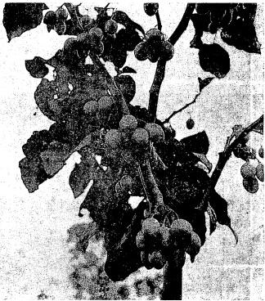
Fig. 4. The.yellow tree tomate is tep vigorous gruwer 0,a,, the red but basesprolafially on Victor Wynne's mountain farm in Haiti. This trop was maturing in tate August. 1982. (Photo by Julia Morton).
83

