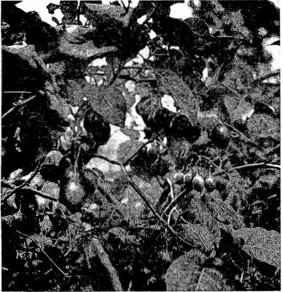
Fig. 3. The rcd stram of troc tomate, turne from green do purpie and then Wood. or rubrred as it riperas. On Victor Wynne's farm abovc Kenscoff. Haiti, at an altitude of 6.000 ft (1828 m), the tree tomato produccs successive trope the year mond. (Photo by Julia Morton).
facilitates harvesting and, if timed appropriately, can ex-tend the total fruiting period. Early sprmg pruning of some of the trees brings about early maturity; fall pruning of other trees delays fruit maturity to the following fall (6, 14, 20, 24).
Irrigation
The tree tomato cannot tolerate prolonged drought and must have an ample water supply during severely dry periods. A mulch is very benefiaal in conserving moisture at such times.
mato in titis situation is remarkably drought-tolerant though the trop is reduced if droughts persist for several months. The tree tomato, thus far, seems an ideal trop for this altitude in Haiti and the attractiveness and superior flavor of the yellow type should encourage it3 planting in protected locations in central Florida (41 and V. A. Wynne, personal communication).
Polllnatlon
Tree tomato flowers are normally self-pollinating. If wind is completely cut off so as not to stir the branches, titis may adversely affect pollination unless there are bees to transfer the pollen. Unpollinated fiowers will drop prematurely (5).
Cropping and Yleld
The tree usually begins to bear when 1.1/2 to 2 yr old and continues to be productive for 5 or 6 yr. If then adequately nourished, it may keep on fruiting for 10 to 12 yr. In Brazil, each tree is expected to yield 44 w 66 lb (20 to 30 kg) of fruit annually (9, 20, 23).
The crop does not ripen simultaneously and several pickings are necesary. The fruits are clipped, leaving about 1/2 inch (12.7 cm) of stem attached. They are collected in bags worn by the harvesters.
In New Zealand, the fruits are sorted by size—small, medium and large—and packed in paper-lined wooden boxes for marketing. Because of its tough skin and firm fiesh, the fruit can be shipped long distances without bruising. However, it deteriorates rather rapidly under ordinary storage conditions (7, 20).
Pesta and Diurèses
The tree tomato is generally regardcd as fairly pestresistant. A )doper caterpillar makes large holes in the leaves of young plants in the nursery but causes utile damage to
